SW1: Scientific Models: Time

In this activity you will conduct several thought experiments and use logic to discover something fascinating about the nature of time and space. You will work in groups of two with a whiteboard.

Part A: Relativity— “Can you tell you are moving?”
Commonsense dictates and experience confirms that there is no mechanical experiment that can be done in a closed room to tell whether or not the room is moving at a constant speed in a straight line.


- Imagine Alice sitting in a parked car, tossing an apple straight up. Later, she
repeats this experiment while the car is moving at a constant speed.
(a) Sketch the path of the apple, as seen by Alice, both when the car is parked and when it is moving.
(b) Can Alice use this experiment to tell that she is moving?
(c) Sketch the path of the apple, as seen by Bob standing on the sidewalk, when the car is moving.

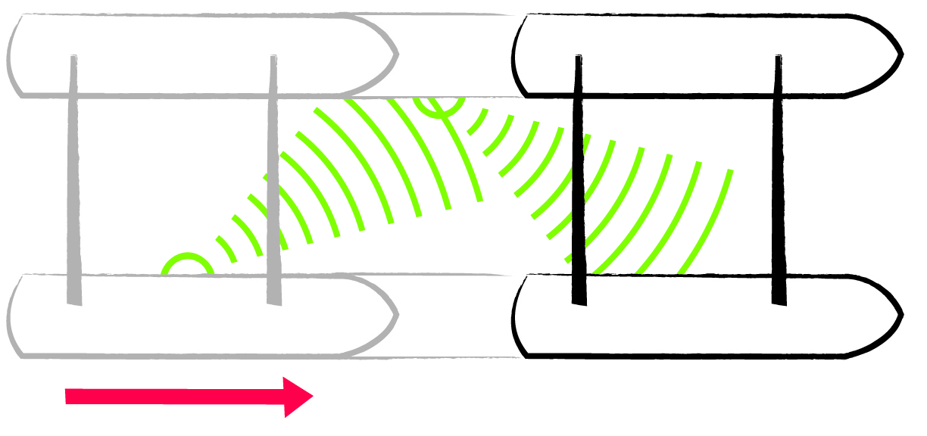
2. Imagine Alice on a raft made from two pontoons joined by a couple of poles.
She anchors the raft in a still pool of water and sends a wave from one pontoon across to the other. It reflects back and she measures the total time taken. Later, the raft is propelled through the water at a constant speed and
she repeats her experiment (see Figure). An important fact to consider is that the speed of a wave produced by a moving source will be the same as the speed of a wave produced by a stationary source.
(a) Sketch the path of the wave Alice observes when the boat is anchored.
(b) Sketch the path of the wave, as seen by Bob floating at rest in the water, when the boat is moving through the water.
(c) Can Alice use the times measured in this experiment to tell that she is moving?

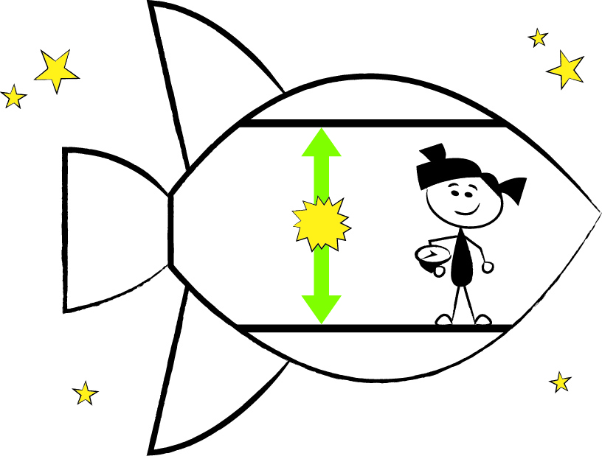
3. Imagine Alice inside a rocket deep in space with a clock that measures the time taken for a pulse of light to go up to a mirror on the ceiling and back again. Alice has learned that light behaves like a wave, and assumes it travels through some medium in space that flows freely through the moving rocket. Suppose she starts at rest in that medium and measures the time taken for the pulse to go up and back again. Later, she repeats the experiment when she is moving at a constant speed. Bob is just floating in space, at rest in the medium. He also times the light pulse as Alice cruises by.
(a) Sketch the path of the light pulse Alice observes when she is at rest.
(b) Sketch the path of the light pulse Bob observes when Alice is moving.
(c) Can Alice use this experiment to tell that she is moving?
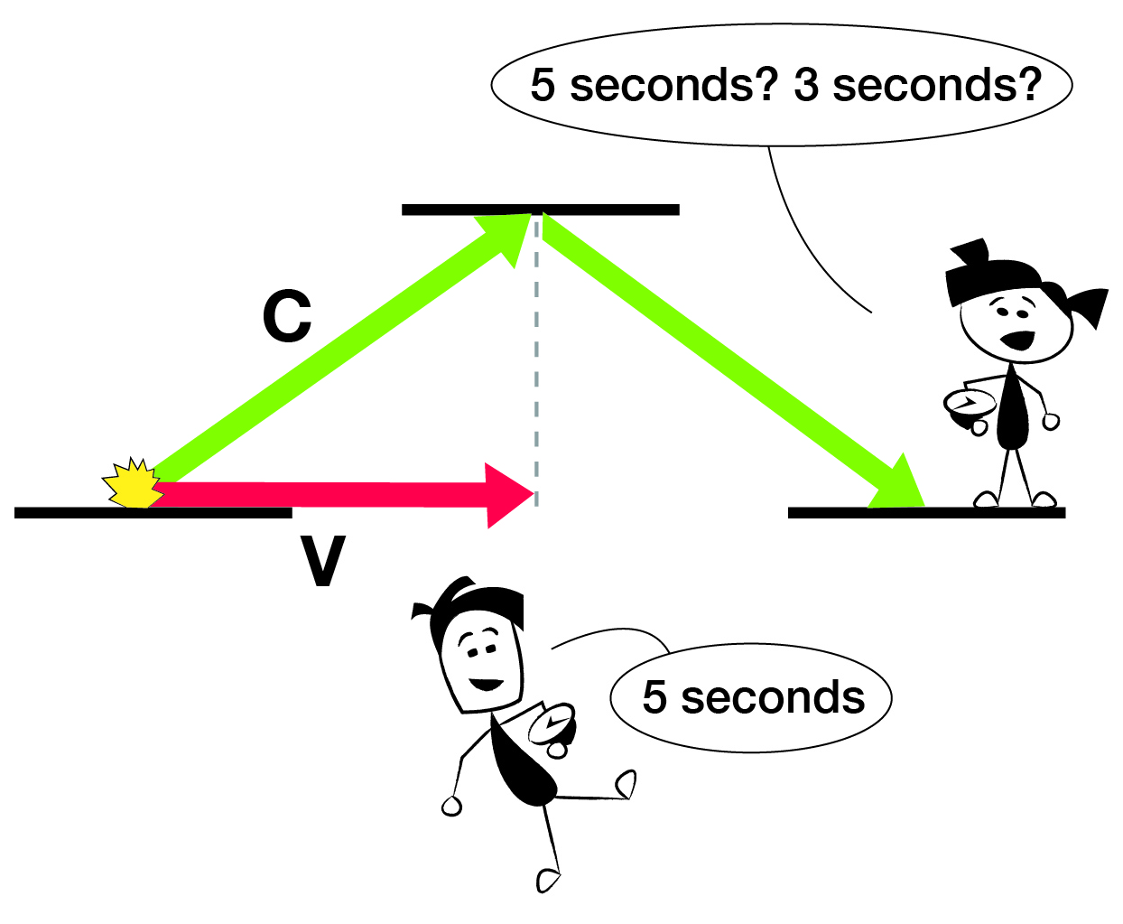
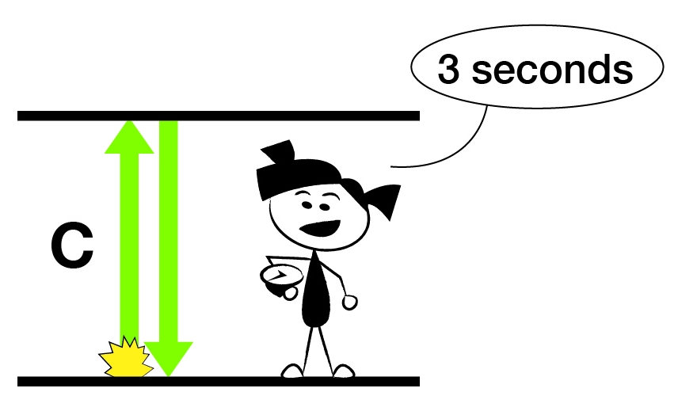
Part B: Newton vs Einstein
Newton believed in absolute time: the rate at which time passes is the same for everyone regardless of their motion. Einstein believed in universal relativity: there is no way to tell, from inside a closed room, that the room is moving. The natural assumption that light waves travel through some medium in space means that the speed of light along both paths in the diagram is the same. Since the path observed by Bob is longer he must record a longer time than Alice did when she was at rest. This puts absolute time and universal relativity into direct conflict—only one of them can be right.
1. Absolute time dictates that in the moving experiment Alice should measure the same time as Bob does. What are the implications for universal relativity if this is true?

2. Universal relativity dictates that in the moving experiment Alice should measure the same time as she did when she was at rest. What are the implications for absolute time if this is true?

Absolute time and universal relativity are incompatible. One of them must be wrong. The only way to resolve the conflict is through experiment.

3. The Large Hadron Collider (LHC) is the largest scientific experiment in history. It is a 27 km long particle accelerator that smashes protons together with unprecedented energy. Neutral kaons are unstable particles produced during the collisions that decay with a half-life of 8.9x10⁻¹¹ s. Use this half-life as the decay time for the kaons.
(a) How far would you expect the kaons to travel before decaying, if they are travelling at 0.995c?
(b) Kaons are detected 27 cm from the centre of the collision. How does this data refute Newton?
(c) How would Einstein interpret these results?

4. Consider again the kaons produced at the LHC. From the perspective of the kaons, they are at rest and they survive for 8.9x10⁻¹¹ s. The kaons “see” the detector rushing by them at 0.995c. How much of the detector do they measure during this time? How can you reconcile this with the 27 cm mentioned above?

A logical consequence of universal relativity is time dilation—“moving clocks run slow”. The flip-side of time dilation is length contraction—“moving objects occupy less space.”

Part C: Time Dilation and Length Contraction
Experimental evidence supports Einstein’s predictions of time dilation and length contraction. With this as motivation, let’s take a closer look at the diagram above for the rocket experiment.

1. According to universal relativity, Alice cannot tell that she is moving. The time taken by the light pulse must be the same for her, whether she is moving or not. Write the algebraic expression for the time taken, t_{Alice}, when Alice is not moving.

2. Bob sees the light pulse travel up and down in the vertical direction, with a vertical speed of 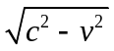 (which simplifies to 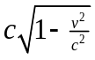). Write the algebraic expression for the time Bob measures, t_{Bob}.

3. Compare t_{Alice} and t_{Bob}. What is the “time dilation” factor that relates Alice’s time to Bob’s time?

4. In the moving case, Bob sees the vertical speed of the light pulse to be . Does this mean that Alice sees the vertical speed of light to be less than c? Explain, using time dilation.

5. When Alice is moving relative to Bob, Alice and Bob disagree on how much time elapses for the light pulse to return. How will this disagreement affect their understanding of how far Alice has travelled in her rocket?

Time and length are both changed by the same amount, the Lorentz factor, and it shows up in so many relativity calculations that it gets its own symbol, γ. Note that γ is always ≥ 1.

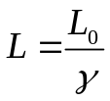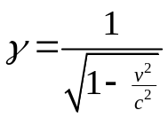
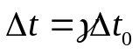

Part D: Speed Limit
One of the misunderstandings about relativity is that Einstein began with the statement that “nothing goes faster than the speed of light” and derived everything from that premise. While this statement is true, it is not fundamental—it is a logical consequence of time dilation and length contraction.

1. Alice is inside her rocket, moving relative to Bob, when she starts running forward at 1 m/s. She covers 1 m in 1 s according to her ruler and clock.
(a) How far is Alice’s 1 m as measured by Bob? (Express your answer in terms of γ.)
(b) How long is Alice’s 1 s as measured by Bob? (Express your answer in terms of γ.)
(c) How fast is Alice running inside the rocket as measured by Bob? (Express your answer in terms of γ.)

2. As Alice begins to run, her speed inside the rocket changes from zero to 1 m/s. How will this speed change appear to Bob? How will this speed change be affected by the speed of the rocket as it gets closer to c?

Time dilation and length contraction “enforce” a universal speed limit, and allow it to make sense.

3. Suppose Alice needs to apply a force F, for one second, to get herself running. Now imagine, instead, that Bob “reaches” into her moving rocket and pushes her with the same force, F. (He stays at rest, but his hand moves very fast!) How long does he need to apply the force, according to his clock, to have the same effect on Alice?

It’s harder for Bob to accelerate Alice, as if her mass somehow increases. Actually, nothing happens to Alice’s mass. It is time dilation and length contraction that make Alice’s effective inertia greater, relative to Bob.

4. Plot the following historical data for particle accelerators with Energy of the proton (in GeV) on the x-axis and Speed of the proton (as a % of c) on the y-axis. What happens to the speed as more and more energy is given to the particle? Where is the energy going, if it’s not going into increasing the proton’s speed?
Proton accelerator | Energy (GeV) | Speed (%c)
CERN Linac 2 | 0.050 | 31.4
TRIUMF | 0.48 | 75
CERN PS Booster | 1.4 | 91.6
BNL Cosmotron | 3.3 | 97.5
CERN PS | 25 | 99.93

Suppose we give a particle some energy to accelerate it from rest up to speed v. By universal relativity we can catch up with the particle and see it as “at rest” again. We can then repeat this process—again and again, forever. While its speed is limited (by the nature of time and space), the amount of energy we can give a particle is unlimited. This is just one of the fascinating ideas contained in Einstein’s most famous equation, E=Mc².

Bringing It All Together

1. Review the work that you have done as a group and discuss any points that need clarification.
Summarize the concepts in your notebook. Be sure to address the following points:
- What is universal relativity and absolute time and how do they conflict with each other?
- What is time dilation and length contraction and how are they related?
- Why is there a universal speed limit?
- List some of the experimental evidence for Special Relativity.
- What happens to an object’s effective inertia as its speed increases?

